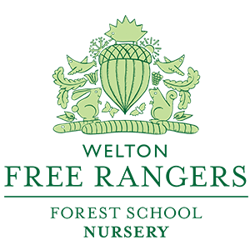

Fire and Outdoor Cooking Policy

Detailed in this policy are the safety procedures and considerations for lighting and cooking on a fire at any Forest School session.

Building Fires on Forest School:

Fires are an integral part of Forest School delivery and leaders will work with a group to ensure they display the correct behaviour and attitudes before lighting fires with them. However, it is important to keep the following guidance in mind in conjunction with our Forest School rule for “Respecting the Fire” (See Risk Assessment Policy) :

- Fire and safety rules: This should have a slow introduction. The rules surrounding the fire area should always be carried out even when there is no fire. This will start in the Hive with experiences around the fire, through the Burrow with the children building up a relationship with it and how to move safely around it at snack times and into the Den where they will use the fire and light their own. New children will also be slowly introduced to fires and their needs catered for.
- Before lighting, a means of extinguishing the fire must be available, whether this is wet sand or water. Furthermore, plenty of clean, cold water must be available for cooling/soothing potential burns, alongside a full stocked and checked fire burn kit. A fire blanket should also be present and, if being lit, the fire guard & carbon monoxide detector should be set up in the yurt.
- The weather should be checked prior to lighting. If very windy, any outdoor fire building should be avoided, and the Yurt fire utilised as a source of heat on cold sessions.
- The Fire Bowl should be set on a level flat surface, ideally with no grass underneath to avoid scorching.
- Children must not run around the fire pit or bowl but should walk around looking out for the other children sat or kneeling around the fire.
- Children should not place items into the fire unless with the guidance of a Forest School Leader/Adult. They should be added at the side of the fire, to prevent hands going over the flames and avoiding unnecessary injury. Furthermore, long hair/loose clothing should be tied back.
- The Forest School leader should light the fire(s) to ensure safety and efficiency. Depending on the children’s age and competence, they may be able to light a fire but only if the Forest School leader is happy with the level of competence and that safety rules have been displayed i.e. during the Holiday Club.
- Use a vegetation free zone (a minimum of 5m clearance) with no low overhanging trees.
- The space from the seating area to the fire pit should be a minimum of 1.5m around the entire radius.
- The area of the fire pit should be kept to a minimum to prevent unnecessary damage to the environment. Regular checks will be made to ensure the upkeep of the surroundings including the fire pit, seating, and state of the ground.
- The wood used to construct a fire pit should be as green as possible to help contain the fire, and prevent having to rebuild the fire pit walls in a short space of time. Also the wood for any seating must be tested for rigidity if it is to be placed around a fire pit.
- The flames of the fire should never reach higher than the knee, unless purpose requires it to be bigger.
- A competent person to be responsible for the fire at all times and to ensure that it is out and safe to leave at the end of the day.
- Fire pit and surrounding area should be maintained, and regular upkeep and checks made of the area to maintain safety.
- It is also important to consider the environmental impact of the fire, and if possible only one site should be used. Should the use determine it, non-marking methods of making fires should be used (i.e. Storm/Kelly Kettles).
- Kindling and Fuel should be kept as dry as possible and replenished after each session for the next group.

Fire Pit Requirements:

The diagram shows a basic requirement for a fire pit and seating area.

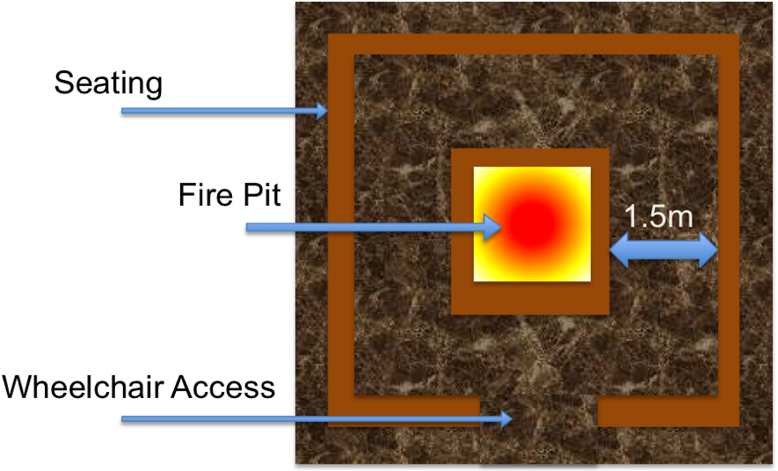

FS Leader Seating

Cooking on Forest School

Cooking is an important part of Forest School sessions at Free Rangers. We have several wild growing plants on site that the children can pick

Cooking considerations and requirements:

- All equipment (plates, utensils, cups, storage boxes) must be cleaned well before use and kept clean prior to use.
- Children should wash hands before touching food and mouths as well as after.
- Any surfaces being used to prepare/cook food on should be cleaned/sanitised before use.
- All persons involved in leading an outdoor cooking session should have a level 2 Food Hygiene Safety Certificate.
- Raw meat should be avoided unless being cooked for children by a competent person with relevant qualification in food hygiene and safety (Food Safety Certificate) and possibly with aid of a temperature gauge to ensure the proper internal temperatures are reached for meat.
- Any allergies/medical conditions should be declared through a medical questionnaire prior to the child’s first session, so that relevant planning can be made for sessions (both in the nursery and the holiday clubs).
- The fire size should be relevant to what is needed. Slow burning woods should be used to produce prolonged heat.

Updated: Mar 2020
Next Review: Jan 2021

