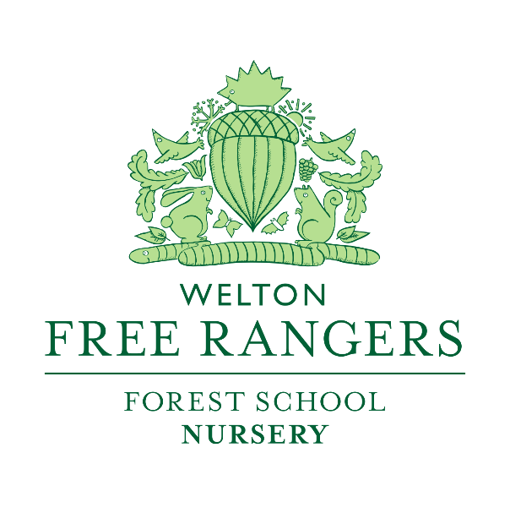
Potty Training Policy
Updated Sept 2018

Most Children will begin to show signs that they are ready for potty training between the ages of 18- 24 Months. At Free Rangers we will offer advice and support parents when they feel the time is right for their child.
Staff at Free Rangers may suggest the time is right to potty train your child if they are:
- Showing an interest in the potty/toilet
- Communicating with staff that they have been /or need to use the potty
- Are bothered by wearing a nappy
- Emotionally and physically ready

At Free Rangers once it is decided that a child will begin potty training consistency and patience is key. To help your child be successful the staff will:
- Take your child to the potty every 15-20 minutes
- Have a ‘potty partner’ for your child so that children can share success and learn with peers. This also prevents children from feeling singled out.
- Celebrate success by using a star/sticker chart for each time your child has had a wee or poo on the potty
- Encourage, support and reassure children when they have an accident
Parents and carers can help us at Free Rangers by:
- Providing your child with changes of clothes (at least 3-4 sets)
- Putting your child in easy clothing, that they can take off themselves if they need to
- Bring in your child’s own potty if you feel this will make them more comfortable
- Being consistent- if they are in pants at nursery try and keep them in pants at home

It is very normal for children to have set backs and for there to be hiccups, however if everyone around the child is consistent, patient and encouraging, children can achieve being potty trained within six weeks or less. If a child does not show any progress it may be suggested that together we stop the process and return to it again when the time is right.
Assisting children in the toilet
At Free Rangers we strive to encourage independence and therefore once children are confident in using the potty/ toilet we encourage the following:
- Pulling their own trousers and pants up and down
- Wiping themselves after they have had a wee
- Washing their hands after using the toilet
- For children who are in their pre-school year and will be leaving for school we will encourage them to wipe their own bottoms.
Staff will assist children depending on their age and level of development, when assisting a child staff will always talk through what they are doing and why for example ‘ I need to wipe your bottom so you do not get sore’. Staff will ensure children’s bottoms are clean and that they are practising good hygiene when using the toilet.
Adopted at Free Rangers September 2014 and updated yearly.

Signed:

