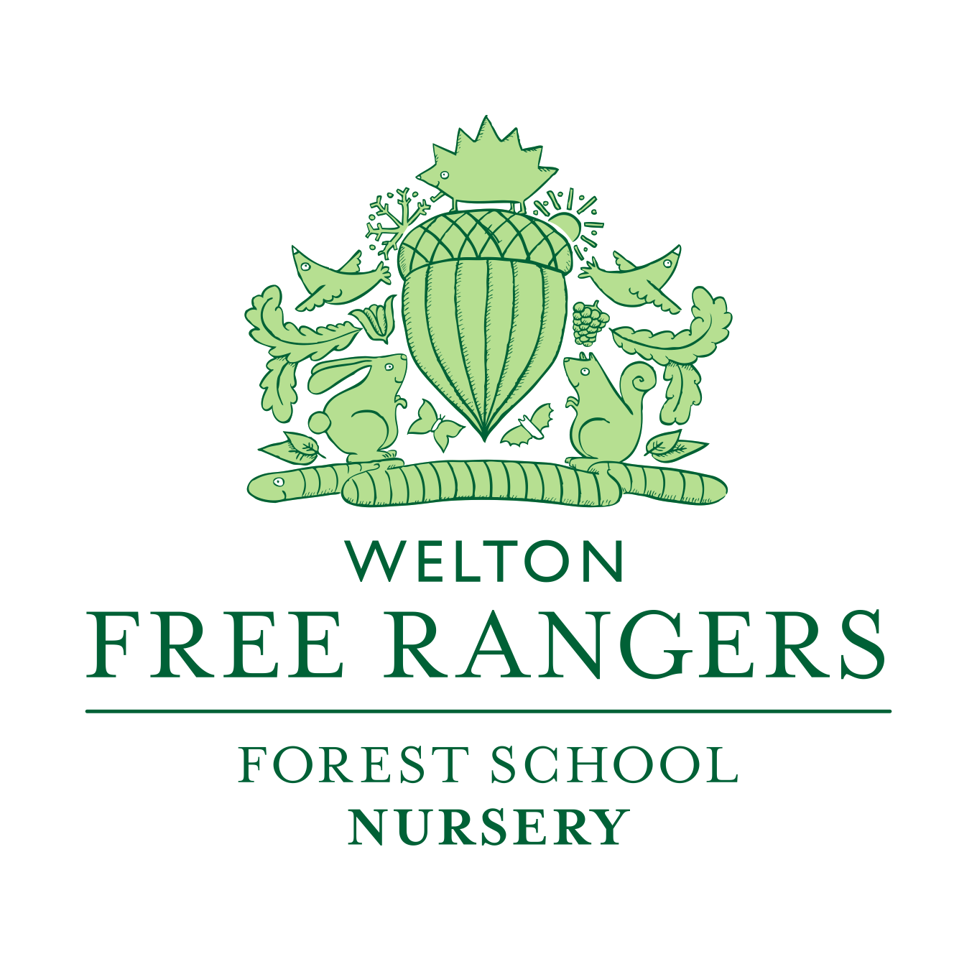

Free Rangers Food Policy
Reviewed February 2021
At Free Rangers Forest Schools Ltd we thrive on the healthy food and drink that is prepared and delivered to the children on a daily basis.
Jayne Adams is our Catering Manager who is a qualified Chef. Jayne has a passion for developing new recipes to encourage children to try new tastes and textures.
Sugar: Where possible we will always use alternative sweeteners, dried fruit, or maple syrup. We avoid using sugar unless naturally occurring.
Wholemeal flours, grains and pastas are used. All our gluten and dairy free products are made from raw ingredients.
Fresh Produce: We use a local organic source and as a very last resort we use supermarket organic produce.
Dried Produce; Essentials (a local company), who follow the same principles as us at Free Rangers, supply our dry organic ingredients
Meat and Fish are supplied by a local butcher and fishmonger who again are very reputable local businesses.
The children at Free Rangers have a range of snacks, which are all homemade, except for the occasional organic crumpet and organic rice cake/cracker. Our snacks contain no artificial additives, colouring or flavouring and most definitely no MSG.
All the food is prepared by Jayne in our own kitchen; which is all produced from raw materials with the exception of sausages these are organic and gluten Free. Free Rangers takes into account all food intolerances and will amend the menu accordingly.
We all are aware of children’s eating patterns and behaviour and how they can differ daily. Therefore, the staff at Free Rangers are observant and recognise foods that are a particular favourite or foods that the children may need a little more encouragement with. Jayne plans her menu on a weekly basis; which is emailed to all our parents/carers. In the baby room there is a communication diary that notes if the children have eaten well and their likes and dislikes.
We pride ourselves on our mealtime manners, trying new foods and enjoying a social time. We always encourage the children to try new foods by putting a little bit on their plate if they are not willing at first. All the children like to serve themselves and will ask for help and question the variety of foods we have.
We help our environment by using eco-friendly cleaning liquids.
Free Rangers continually update and source the best products for the health and well-being of the children and the environment.
As part of our ethos of providing the best for children at Free Rangers we follow some strategic targets:
1 – To cook using traditional methods
2 – To provide a natural balance of foods that promote a healthy immune system
3 – To give children a good understanding of energy obtained from quality meals
4- To show children how food grows and how it ends up on our plates
5 – To cook using utensils which will not affect our children’s well-being i:e: Aluminium and Tefal
6 – To provide a variety of seasonal based foods
Free Rangers ensures that our Food Policy runs parallel to the recommendations from the Early Years Foundation Stage and sisters the ethos of Forest School approach; ensuring the all-round development of the Unique Child is met. We also follow the ‘Eat Better, Start Better’ guide.
All of our staff, within the first 8 months of their time with us will be expected to attend a Level 2 Food Hygiene course. This will be funded by Free Rangers. Up until this point, during their induction new staff will be shown the intolerances boards and be shown the practices we follow to ensure food hygiene and health and safety standards are met and adhered to.
Please see our Health and Safety audit to understand the food safety controls within the kitchen and other snack preparing areas.
Reviewed Jan 2017 and again in Sept 2018
Signed Role
Signed Role

