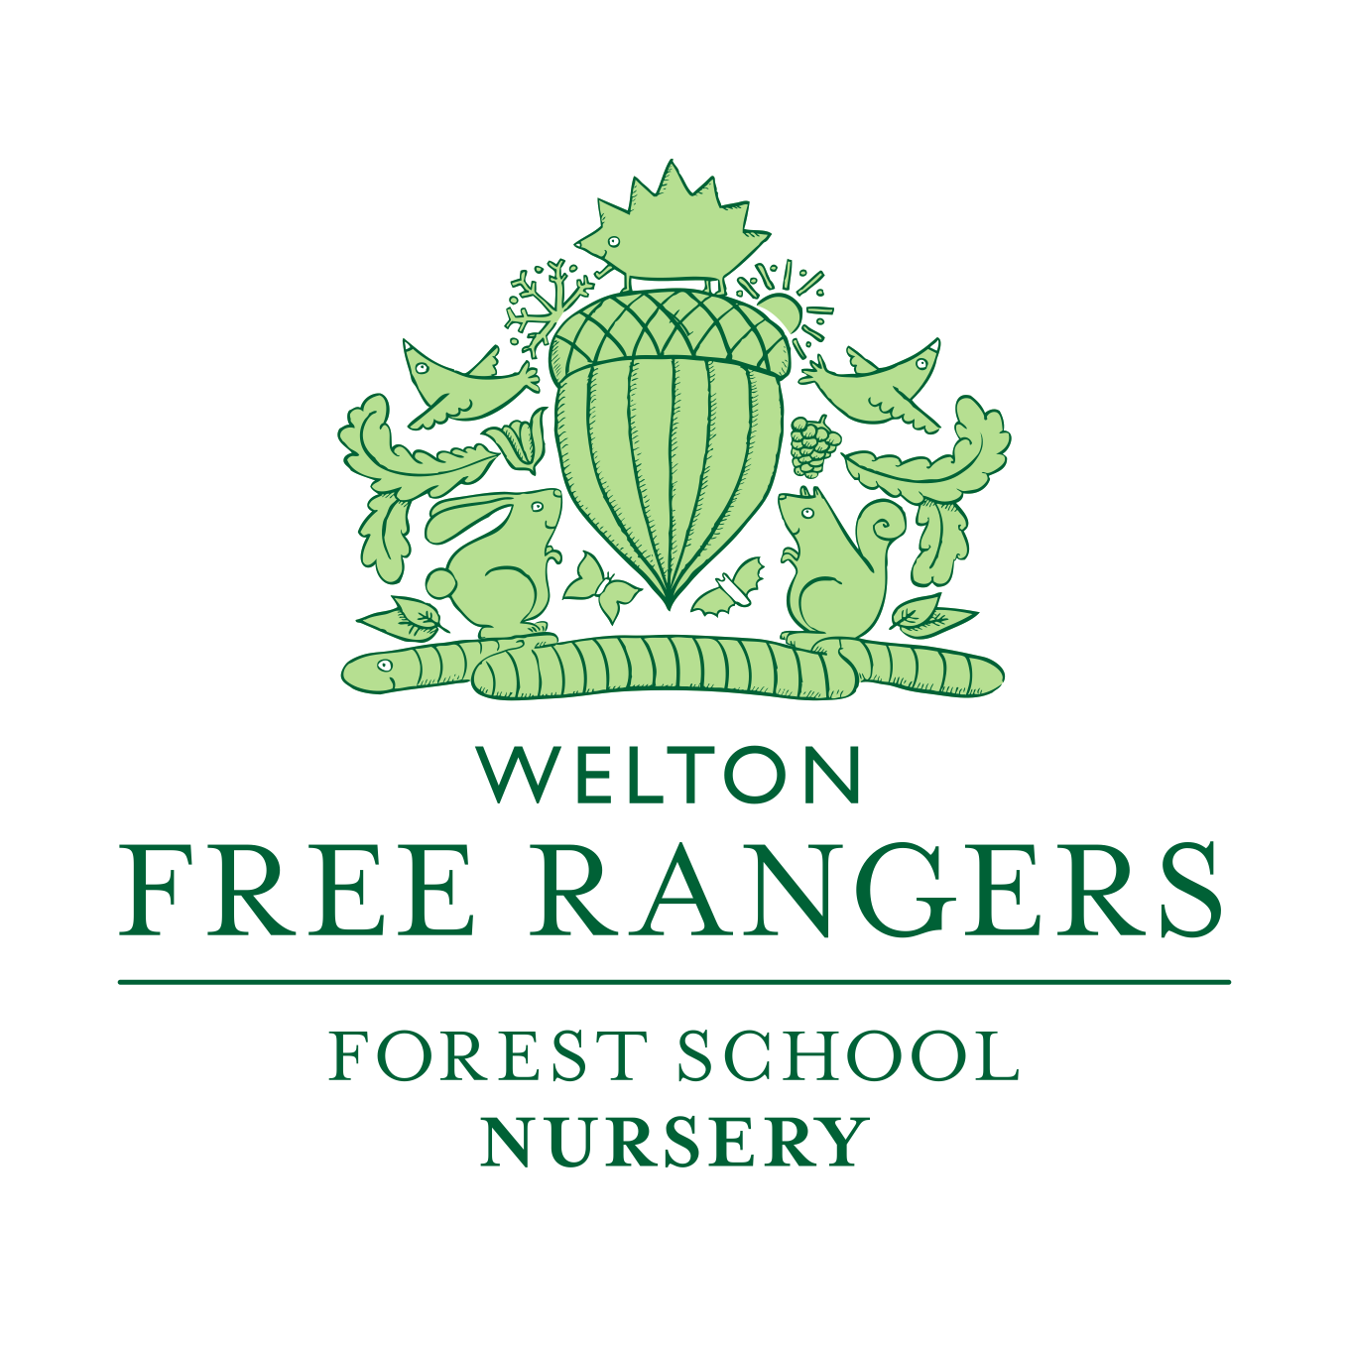
Student Placement policy
Reviewed March 2021
At Free Rangers Forest Schools ltd we recognise that the quality and variety of work, which goes on in the nursery, makes it an ideal place for students. We welcome students who are on placement from school, college or university doing childcare or relevant courses.
Students are welcomed into Free Rangers on the following conditions:
- The needs of the children are paramount.
- Students will not be admitted in numbers which hinder the essential running of the nursery.
- Students required to carry out child studies will obtain written permission from the parents of the child/ren to be studied.
- Students must be confirmed by their tutor as being engaged in a bona fide childcare course, which provides necessary background understanding of children’s development and activities.
- Any more information gained by the students about the children, families or other adults in the nursery school must remain confidential. Records of this information will be held at the nursery.
- Students will never be left unattended with children.
- Unless registered as a fit person, a student will not have unrestricted access to children. If for any reason the staff, children or parents are unhappy with a student then it will be necessary for he or she to leave immediately.
- Staff/ volunteers/ students under the age of 17 cannot count towards the ratio and should be always supervised.
- Individuals aged 17 and over who are on a long-term placement may be included in the ratios if the provider is satisfied they are competent and responsible.
- All students will be required to complete an induction, covering basic risk assessment procedures, fire evacuation procedures and safeguarding procedures amongst other policies and procedures.

This policy was first adopted at a meeting of Free Rangers held on 1st August 2011. And reviewed in Jan 2017. Reviewed again Sept 2018.

Signed: Role: Owner

Signed: Role: Nursery Managers

